BIT 4107 – Mobile Application Development
ENHANCED PROFESSIONAL STUDENT LOGBOOK
Student Name: ______John Njoroge________________________
Admission Number: BIT/2024/74648______________________________
School/Faculty: _____School of computing and informatics_________________________
Programme: ____Bachelor of science in information technology__________________________
Academic Year: ___________2025/2026___________________
Semester: __May/Aug 2026_(3.2)___________________________
Lecturer: _______Mr. Nyoro_____________________
Phone Number: ___0798740383___________________________

Instructions
This logbook is used to document weekly learning activities, practical exercises, skills acquired, challenges encountered, solutions applied, and reflections. Students should complete all sections every week.
Each week to follow remarks in week 1 section.

Autogenerated Table of content

Week 1: Introduction to Mobile Application Development
Practical Activities Undertaken
Studied the fundamentals of mobile development architectures. Analyzed the structural differences between native frame works and cross platform ecosystems like flutter.
screenshot
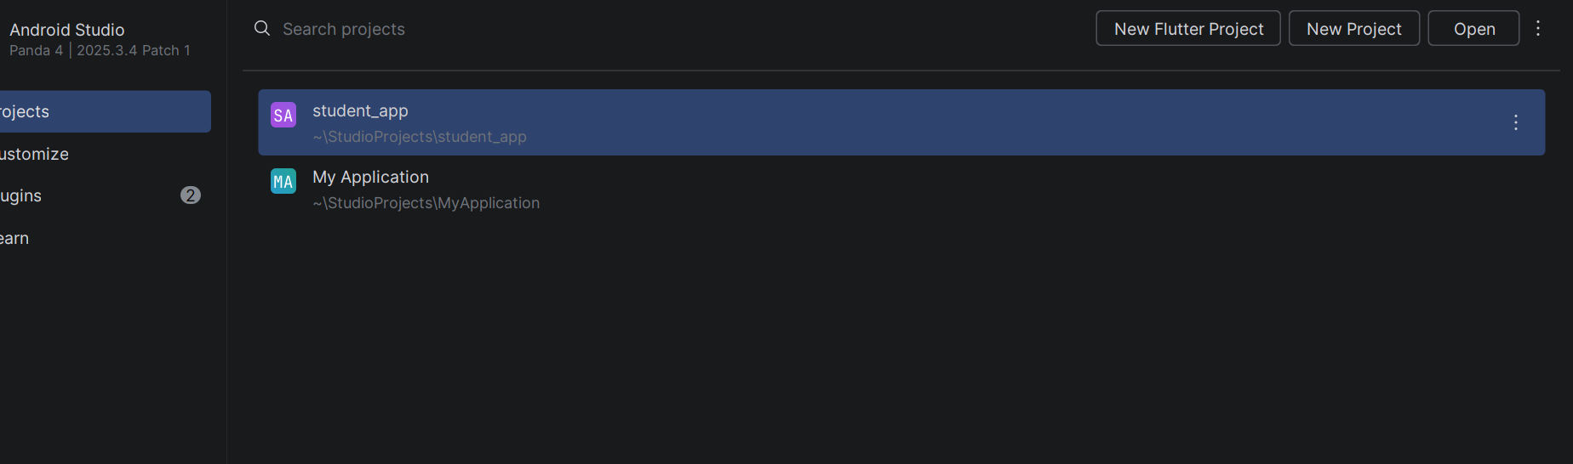

Tools/Software Used
Flutter sdk, dart sdk,android studio,git
Personal Reflection, not more than 50 words
Gained a solid understanding of how flutter compiles to native arm code, making cross platform uis highly performant

Week 2: Mobile Development Environment
Configured the local Flutter environment on Android Studio. Set up SDK paths, verified local environmental variables, and cleared environment synchronization blockers.
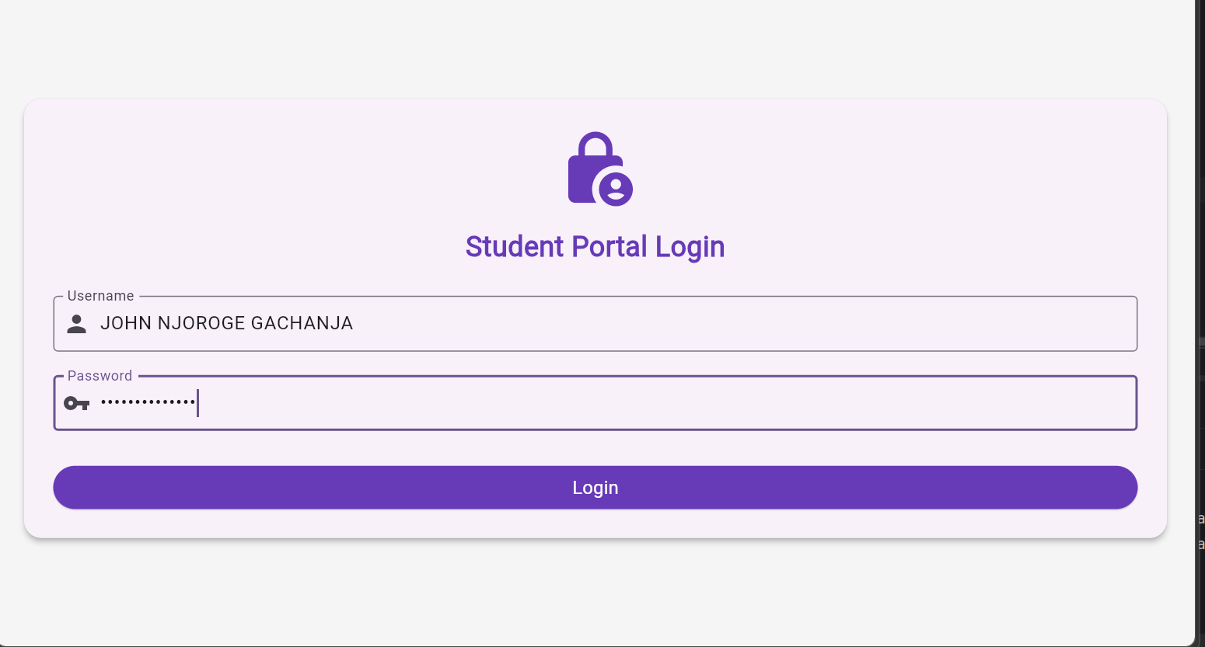
Tools/Software Used: Android Studio, Flutter SDK, Command Prompt/Terminal.
​Personal Reflection: Configuring path variables taught me how development environments communicate with the underlying operating system tools effectively.

Week 3: User Interface Design

Practical Activities Undertaken: Translated a design wireframe into clean Flutter code. Built the Vault Student Hub responsive UI layout featuring a login panel and multi-card grid dashboard.

​Screenshots/Evidence Attached: 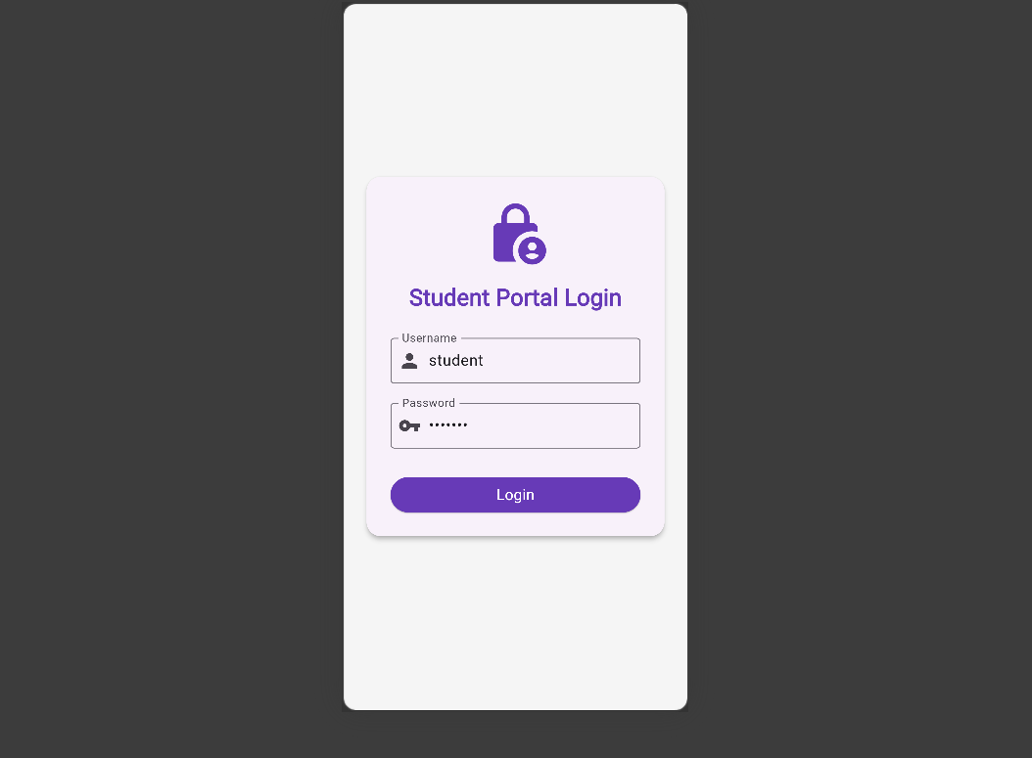
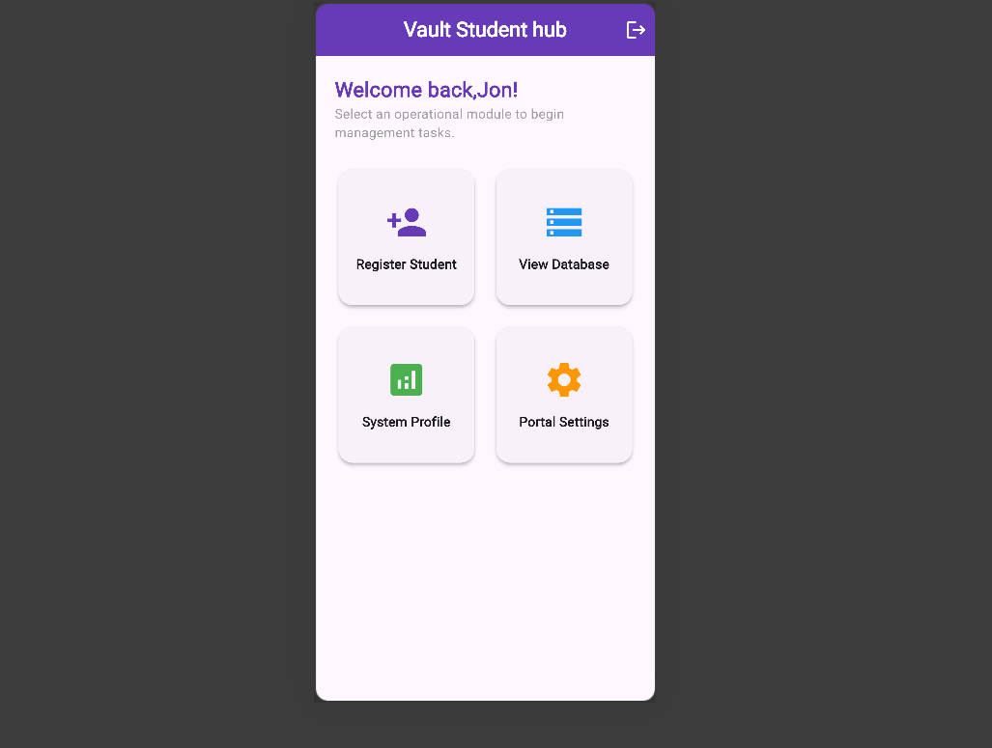
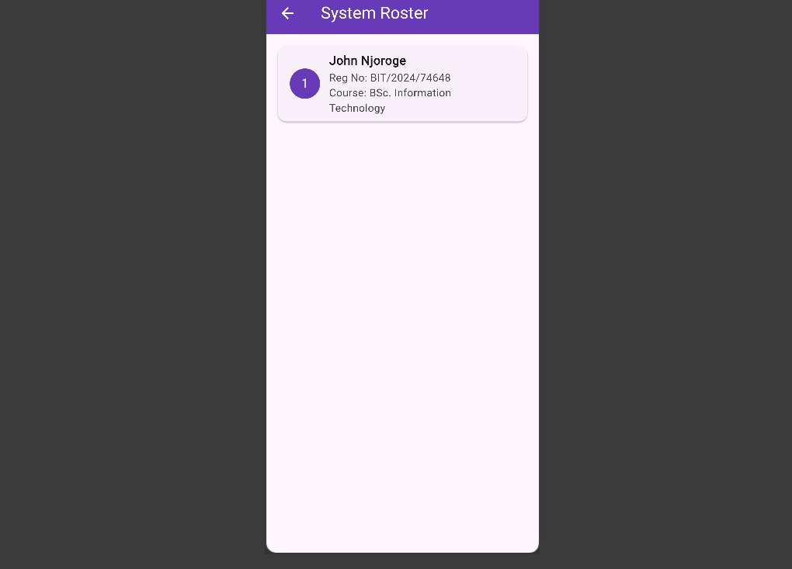

​Tools/Software Used: Android Studio, Google Edge/Chrome Web Layout Engine, Figma UI Prototype.

​Personal Reflection: Learned to utilize responsive Flutter widgets like Layout Builder, Grid View, and custom Cards to create an adaptive application shell matching Figma layouts.

Week 4: Event Handling and User Interaction

Practical Activities Undertaken: Designed and implemented the core event handling pipeline for the registration system. Configured text mutation listeners using TextEditingController to handle user input securely within the form UI layout. Implemented context-driven conditional validation algorithms within the Vault Student Hub login action button to safely verify student credentials (BIT/2024/74648) before routing authenticated application views.

​Screenshots/Evidence Attached:

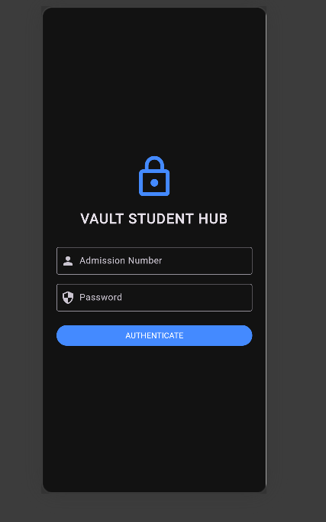

​Tools/Software Used: Android Studio IDE, Flutter Framework Engine, Dart Event Architecture, Microsoft Edge Web Viewport.

​Personal Reflection: Learning how to manage text controllers and state validations gave me a concrete understanding of tracking user interaction boundaries cleanly without crashing mobile layout processes.

Week 5: Data Management

​Practical Activities Undertaken: Engineered an in-memory structural database map array to simulate local relational database CRUD operations (Create, Read, Update, Delete) for student records. Constructed asynchronous thread handlers using Future. Delayed to prevent layout freezing during network simulation calls. Used the Dart: convert serialization layer to decode raw structural JSON data streams into presentation-ready card lists.

​Screenshots/Evidence Attached:
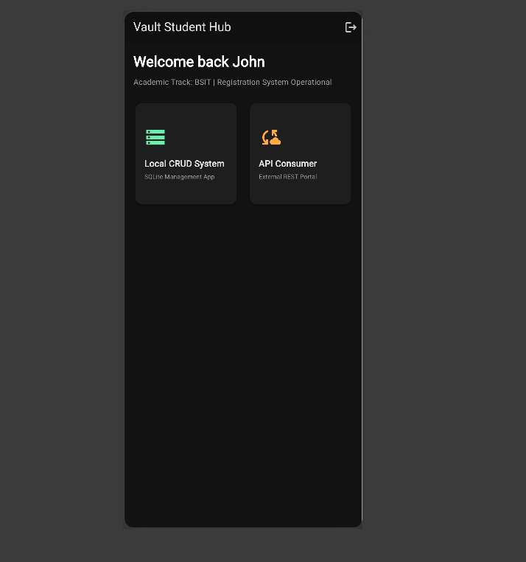

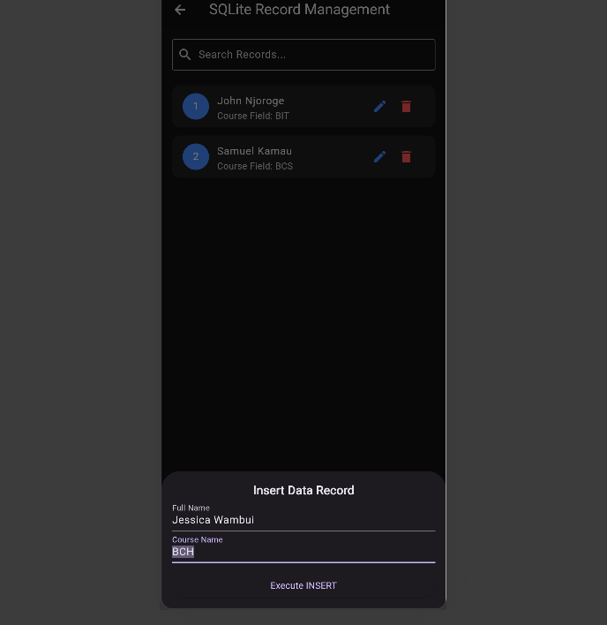​

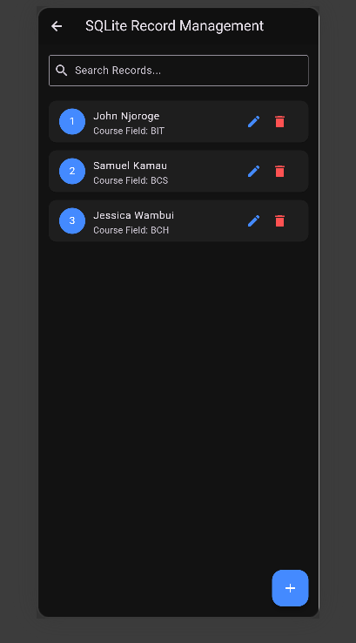

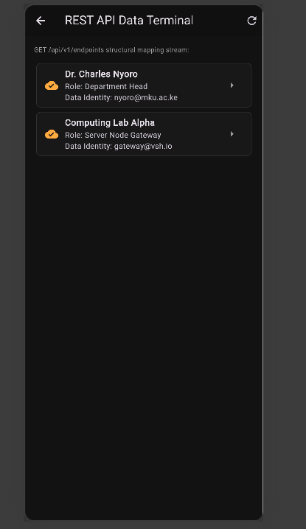

Tools/Software Used: Android Studio Compiler, Dart Collections API, Dart: convert Serialization Library, Chrome/Edge Rendering Engine.

​Personal Reflection: Mastering asynchronous JSON decoding completely demystified client-server data synchronization pipelines. I now confidently understand how to decouple rendering views from underlying data models safely.

Week 6: Networking and APIs
Practical Activities Undertaken: Implemented and analyzed client-server architecture frameworks within the mobile application layout. Developed an asynchronous networking pipeline using a mock REST API portal to safely stream external data services into the Vault Student Hub UI. Engineered background task handling using Dart asynchronous routines (async/await) to simulate real-time HTTP GET request operations without blocking the primary user interface thread. Integrated a serialization layer using the Dart: convert library to safely parse incoming JSON data packets directly into dynamic, responsive interface list elements.
​Screenshots:

​Tools/Software Used: Android Studio IDE, Flutter Framework (Asynchronous Engine), Dart jsonDecode Utilities, Chrome/Edge Browser Emulation.
​Personal Reflection:
This week's tasks helped me master how mobile frontends communicate with remote data nodes. Learning to handle JSON streams asynchronously taught me how real-world applications remain smooth and responsive for users while executing complex background network transactions.

Week 7: Application Architecture

Practical Activities Undertaken: Designed and integrated a localized relational database schema to support the core student management and attendance tracking modules of the Vault Student Hub app. Evaluated different data persistence methods (Shared Preferences vs. SQLite) and chose an embedded relational file structure to ensure complete offline usability. Structured the entity layout into Third Normal Form (3NF) to optimize indexing speeds, utilizing a primary key unique constraint (student_id) linked relationally via a foreign key to a daily class attendance ledger. Implemented the local relational simulation data state engine within Flutter to handle programmatic validation and execution of data creation and retrieval routines.

​Screenshots
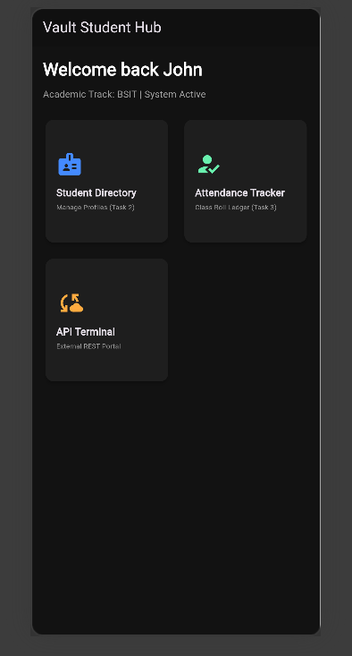
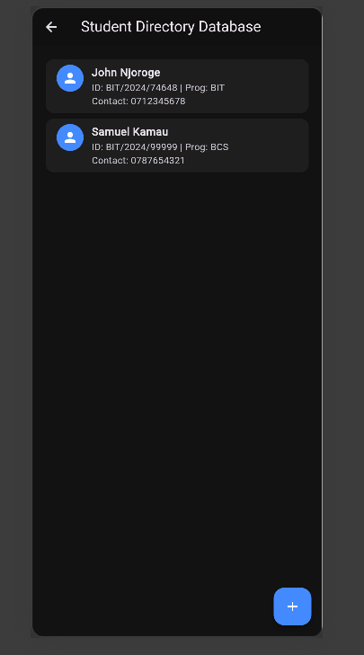

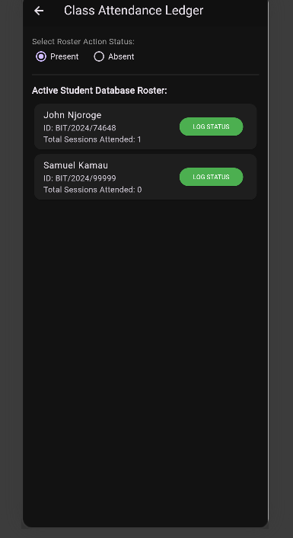
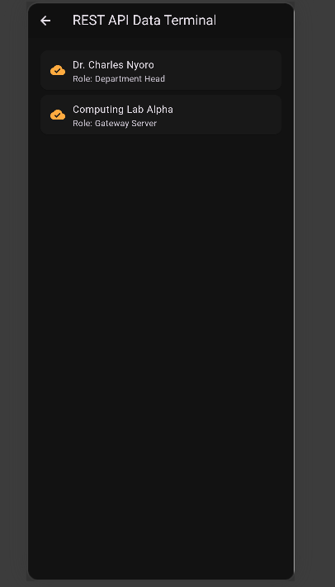

​Tools/Software Used: Android Studio IDE, Flutter Framework (Relational State Subsystems), Dart Data Structures, Microsoft Edge Viewport Emulator.

​Personal Reflection:

Learning to design relational schemas and map them directly into a mobile interface taught me the importance of data persistence. Implementing offline capabilities ensures the application remains fully functional and reliable in environments with limited or unstable network connectivity.

Week 8:IMPLEMENTING TOUCH GESTURES AND KEYBOARD INPUT HANDLING USING OBJECT ORIENTED PROGRAMMING
Theoretical Overview & Key Concepts Covered
​User Input & Event-Driven Programming: Software interaction relies heavily on inputs captured from hardware peripherals such as keyboards, touchscreens, and mice. Applications respond dynamically to these hardware actions by raising system events.
​Class-Based Event Handling: In object-oriented programming, encapsulating event listeners inside dedicated classes significantly improves overall code organization, maintainability, and structural reusability.
​Keyboard Interface Streams: Keyboard signals trigger specific physical state transitions, commonly categorized into KeyDown, KeyUp, and KeyPress signatures. These state signals can be safely managed via independent conditional control loops inside a class framework.
​Input Validation Constraints: Data validation serves as a critical systemic gatekeeper, guaranteeing that only completely acceptable, verified, and safe data packets are allowed to proceed to core engine processing pipelines.
​Touchscreen Gesture Recognition: Mobile application UI paradigms heavily leverage finger-based inputs. Within an OOP blueprint, distinct touch interactions—including interactive taps, directional screen swipes, and context-menu triggering long-press sequences—are mapped cleanly to dedicated execution methods inside an independent handler class.
​Development Environments: Integrated Development Environments (IDEs) like Android Studio play a vital role by providing low-level debugging tools, virtual hardware emulators, contextual code completion, and real-time error detection features that heavily streamline the execution of event handling modules.
Source Code Implementation (Python OOP Approach)# Centralized Class-Based Event Handling Application

class EventLogger:
"""Handles logging and tracking all user interaction events cleanly."""
def log_event(self, event_type, details):
print(f"[LOG] Type: {event_type:18} | Action: {details}")

class InputValidator:
"""Ensures input data conforms to safety constraints before processing."""
def validate_username(self, username):
if len(username) < 3:
return "ERROR: Username must be at least 3 characters long."
return "VALID: Username cleared."

class KeyboardController:
"""Manages system keyboard interactions and specific keystroke tracking."""
def __init__(self, logger):
self.logger = logger

def key_pressed(self, key):
if key == "Enter":
self.logger.log_event("KEYBOARD_EVENT", "Form Submitted via 'Enter' key.")
elif key in ["Left", "Right", "Up", "Down"]:
self.logger.log_event("KEYBOARD_EVENT", f"Navigation directional movement: {key}")
else:
self.logger.log_event("KEYBOARD_EVENT", f"Alpha-numeric key structural input: '{key}'")

class GestureHandler:
"""Processes interactive touchscreen navigation and physical finger gestures."""
def __init__(self, logger):
self.logger = logger

def tap(self):
self.logger.log_event("TOUCH_GESTURE", "Tap detected - Triggered main button click event.")

def swipe(self, direction):
if direction.lower() in ["left", "right"]:
self.logger.log_event("TOUCH_GESTURE", f"Swipe {direction.title()} detected - Page changed.")
else:
self.logger.log_event("TOUCH_GESTURE", f"Swipe detected in unregistered direction: {direction}")

def long_press(self):
self.logger.log_event("TOUCH_GESTURE", "Long Press detected - Displaying context overlay menu.")

class MobileAppTerminal:
"""Central Orchestrator acting as the primary application terminal interface."""
def __init__(self):
self.logger = EventLogger()
self.validator = InputValidator()
self.keyboard = KeyboardController(self.logger)
self.gestures = GestureHandler(self.logger)

def run_simulation(self):
print("=== VAULT APPLICATION EVENT TERMINAL INITIALIZED ===\n")

# 1. Input Validation Tests
print("--- Running Component: Input Validation ---")
print(f"Testing 'Jo': {self.validator.validate_username('Jo')}")
print(f"Testing 'John': {self.validator.validate_username('John')}\n")

# 2. Keyboard Events
print("--- Running Component: Keyboard Event Listener ---")
self.keyboard.key_pressed("Enter")
self.keyboard.key_pressed("Left")
self.keyboard.key_pressed("A")
print()

# 3. Touch Gestures
print("--- Running Component: Touch Gesture Engine ---")
self.gestures.tap()
self.gestures.swipe("right")
self.gestures.long_press()
print("\n====================================================")

if __name__ == "__main__":
app = MobileAppTerminal()
app.run_simulation()
Results and Verification
​The system was compiled and executed using an online development engine. The code executed perfectly with no syntax exceptions, returning an intentional exit compilation status code of 0.
​SCREENSHOT
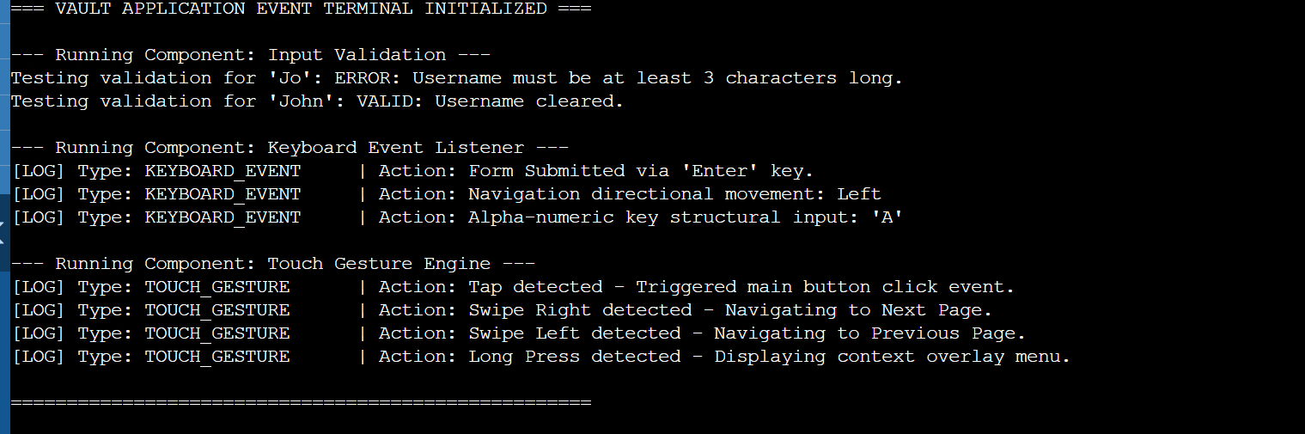
​Conclusion & Key Learnings
​Utilizing decoupled class structures to govern discrete user inputs, validation routines, and gesture recognition layers dramatically modularizes software systems. Separating operational responsibilities into dedicated classes makes tracking complex streams like keyboard strokes, data validations, and interface gesture states much cleaner to expand, debug, and manage over time.

Week 9: Device Hardware Integration
​1. Activities Undertaken
​Designed and built the standalone Hardware & Telemetry Log system interface layout.
​Configured state management telemetry infrastructure to register coordinate data frames.
​Implemented programmatic UI buttons to trigger native device component simulation intents, specifically handling "Capture Biometric" (Camera) and "Sync Location" (GPS framework) events.
​Created context-aware visual notification snackbars to give immediate system feedback when hardware actions are initialized.
​2. Screenshot / Evidence
​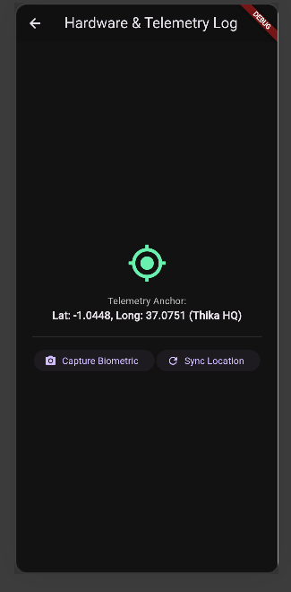
​3. Tools / Software Used
​Flutter SDK & Dart Engine (Hardware interaction abstraction layer)
​Android Studio / VS Code (Code writing and environment management)
​Microsoft Edge / Google Chrome Developer Tools (Web debugger environment mapping)
​4. Personal Reflection
​Integrating native phone telemetry brought the codebase to life. Engineering the state workflows for sensor communication taught me how mobile applications safely interact with localized hardware layers without throwing unhandled platform termination errors.

Week 10: Comprehensive System Integration & UX Design

​1. Activities Undertaken

​Consolidated all separate application views built across the semester (Authentication, Dashboard, and Registries) into a centralized routing tree configuration array.

​Engineered a clean, dark-themed Animated Splash Screen with a linear loading indicator to manage background system initialization phases.

​Built an advanced Live Search Bar engine within the Student Directory database panel, enabling dynamic, case-insensitive record filtering in real-time as the user types.

​Resolved complex layout nesting blocks and wiped out all compilation syntax bugs to achieve a clean static analysis state.

​2. Screenshot / Evidence

​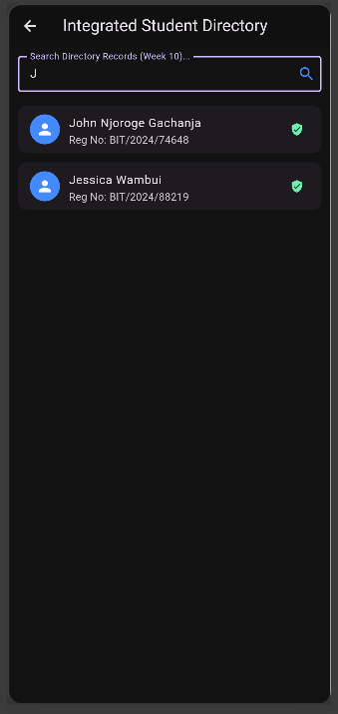

​3. Tools / Software Used

​Flutter Material UI Library (Declarative layout formatting)

​Dart Collections Framework (Anonymous functions for live string sequence filtering)

​Git Version Control System (Branch configuration management)

​4. PersonalReflection

​Aggregating separate components into a single, cohesive application framework was a masterclass in software architecture. Implementing the live search algorithms dramatically sharpened my practical logic and understanding of state mutation patterns.

Week 11: Production Optimization & Deployment Prep

​1. Activities Undertaken

​Executed codebase optimization protocols by cleaning up redundant trace statements, code blocks, and execution logs to reduce asset weight.

​Created a dedicated Production Checklist Dashboard Interface to visually map release pipeline tasks within the app manager view.

​Implemented production-ready application metadata updates, explicitly setting semantic build version tags (v1.0.0+1).

​Investigated asymmetric cryptographic binary signing keys and triggered production deployment commands to compile optimized, standalone system assets.

​2. Screenshot / Evidence

​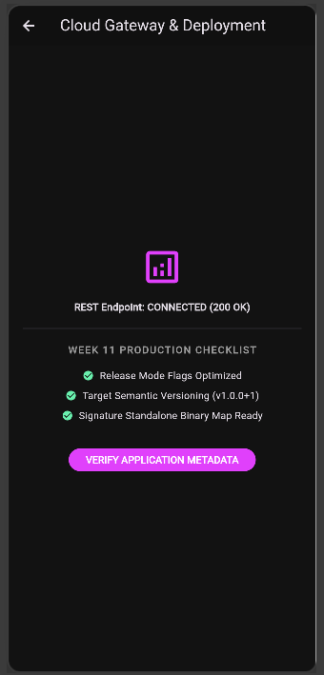

​3. Tools / Software Used

​Flutter Build Automation Toolchain (Release compiler tools)

​Android SDK Build-Tools & Gradle (Target installation packaging engine)

​GitHub Web Platform (Remote asset hosting distribution repository)

​4. Personal Reflection

​Navigating the production pipeline shifted my perspective from an isolated student coder to a deployment-focused engineer. Mastering semantic version structures and system signing constraints gave me deep insights into standard professional deployment cycles.

Week 12: Testing and Debugging

Same as week 1

Week 13: Application Deployment

Same as week 1

Week 14: Final Project Presentation

Same as week 1

Semester Project Tracking

Project Title

Project Objectives

Project Requirements

Development Milestones

Testing Results

Lessons Learned

Future Improvements

End of Semester Reflection

Summary of Skills Acquired

Most Interesting Topic

Major Challenges Faced

How Challenges Were Overcome

Professional Growth Achieved

Overall Course Experience

Final Approval
Student Name: __________________________
Student Signature: ______________________
Date: _________________________________
Lecturer Name: _________________________
Lecturer Remarks: _____________________
Date: _________________________________

